A000-Mex-Moche-Smiling Anthropomorphic Deity-Stirrup Jar-Ceramic-450-500 CE

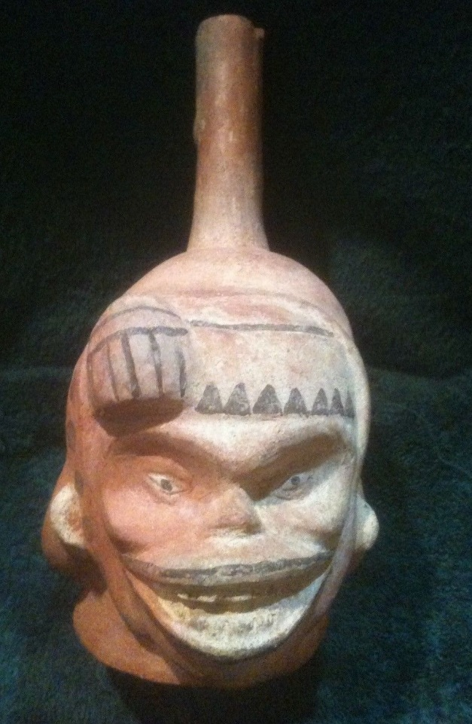 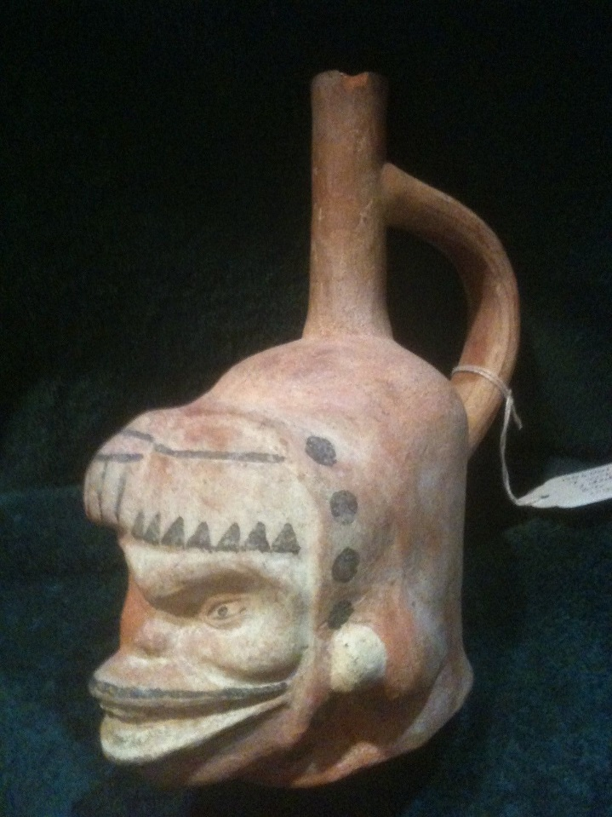 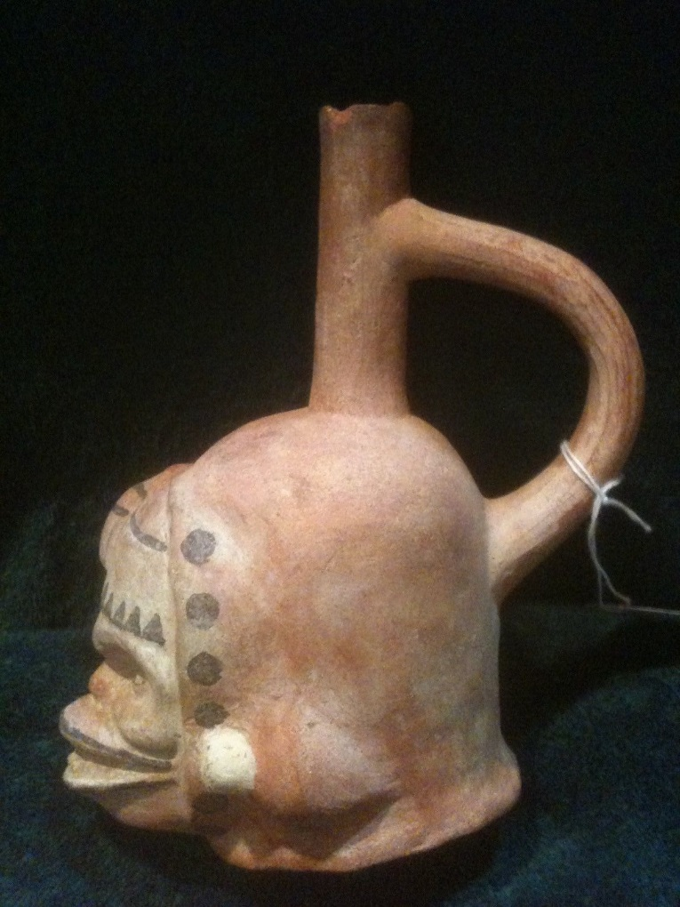

Mex-Moche-Smiling Anthropomorph-Stirrup Jar-Ceramic-450-500 CE

**Case No.: 10**

Accession No.

Formal Label: Mex-Moche-Smiling Anthropomorph-Stirrup Jar-Ceramic-450-500 CE

Very rare Moche IV Smiling Anthropomorphic Deity Stirrup Jar- Very creepy and attractive piece of a smiling god.  The smile is grinning and the facial shows sunken eyes and a large bum on the forehead. Large stirrup runs from chimney to back of head.

Display Description:

LC Classification:

Date or Time Horizon:

Geographical Area:

Map:

GPS coordinates:

Cultural Affiliation:

Media:

Dimensions: size: 8 inches tall, 3 1/2 in wide, 6 1/2 inches deep

Weight:

Condition:It has two tiny chips on the top of the chimney but is in good shape with faded paint still there with some minor surface scratching.

Provenance: Ex: Arte Xibalba consignment. Provenance: ex; Andrea Sarmiento private collection; Miami, FL; ex: Llerena Family private collection, Miami, FL; ex: Arte Xibalba, collection and dealer, Sarasota, FL; ex: Walter Young MD, Private Collection, Colorado Springs, CO

Discussion:

References: